Term |  |  | Term 1 |  |  |  |  |  |  |  | Term 2 |  |  |  |  |  |  | Term 3
Reception | Main project |  | 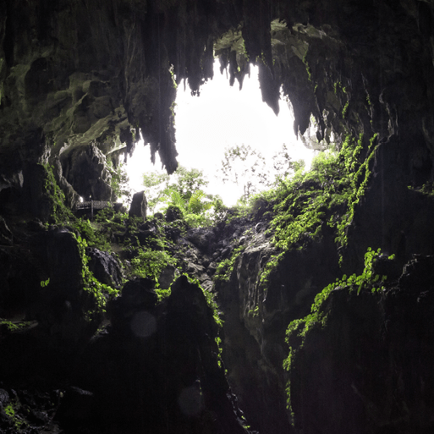  Let’s Explore |  |  |  |  | Marvellous Machines |  |  | 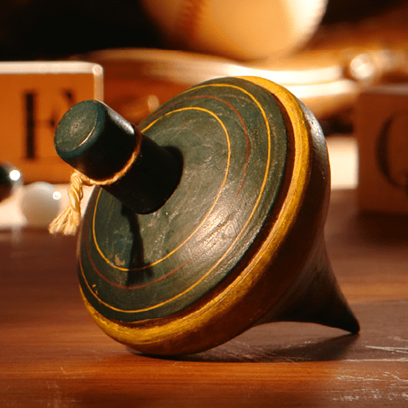  Long Ago |  |  | 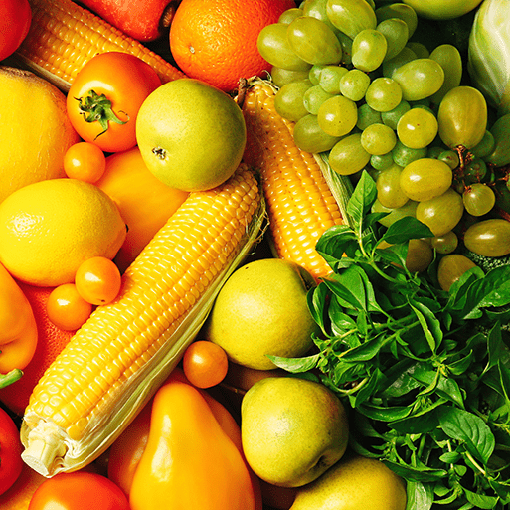  Ready Steady Grow |  |  |  | 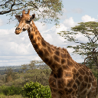  Animal Safari |  |  |  |  | 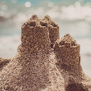  On the Beach
 | Mini project |  | Build It Up |  |  |  |  | Puppets and Pop Ups |  |  | Stories and Rhymes |  |  | Signs of Spring |  |  |  | Creep, Crawl and Wriggle |  |  |  |  | Move It
 |  |  |  |  |  |  |  |  |  |  |  |  |  |  |  |  |  |  |  |  |  |  | Moving on
Main theme |  |  | History |  |  |  |  |  |  |  | Geography |  |  |  |  |  |  | History
Year 1 | Main |  | 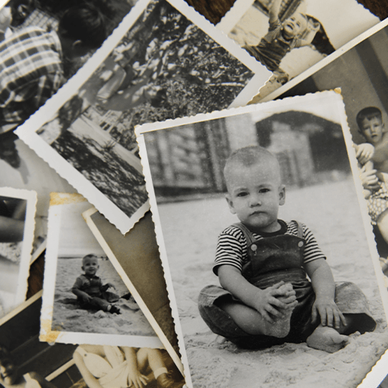  Childhood |  |  |  |  |  |  |  | Bright Lights, Big City |  |  |  |  |  |  | 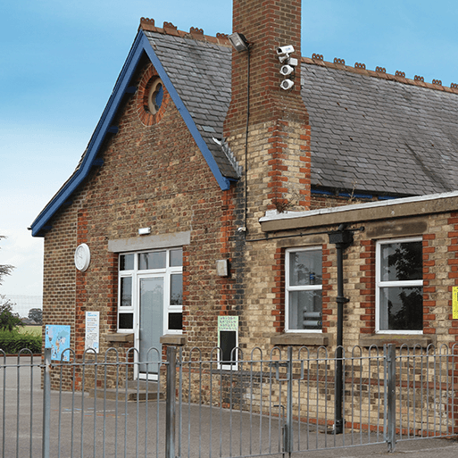  School Days
 | English pack genres |  | Autobiographies |  | Non-chronological reports |  |  |  | Riddles |  | Information posters |  | Directions |  |  | Narratives |  | List poems |  | Diaries |  |  |  |  | Letters
 | Whole Class Read
 | Mini projects | Science | Everyday Materials |  |  |  |  | Humans |  |  | Seasonal changes |  |  |  |  |  |  | Plants |  |  |  |  | Animals
 |  | Art | Mix it |  |  |  |  | Funny faces and fabulous features |  |  | Rain and sunrays |  |  |  |  |  |  | Street view
 |  | DT | Shade and shelter |  |  |  |  |  |  |  | Taxi |  |  |  |  |  |  | Chop, Slice, Mash
 |  | Geog | Pre-requisites for Year 1- some Our Wonderful World |  |  |  |  |  |  |  | Covered in main project |  |  |  |  |  |  | Geography revision and retrieval practice
 |  | History | Covered in main project |  |  |  |  |  |  |  | Recap and revision |  |  |  |  |  |  | Covered in main project
Year 2 | Main |  | 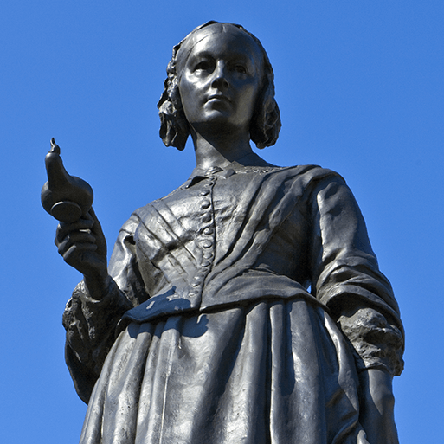  Movers and Shakers  History |  |  |  |  |  |  |  | 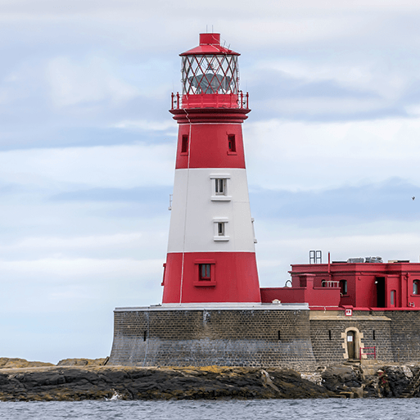  Coastline  Geography |  |  |  |  |  |  | 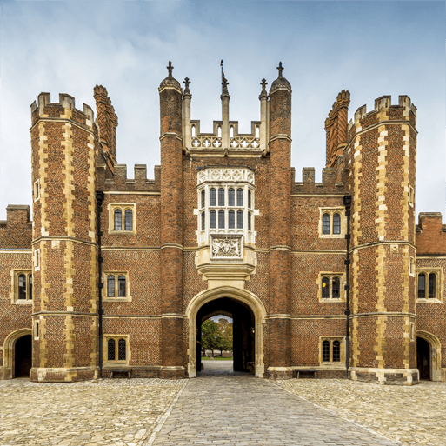  Magnificent Monarchs  History
 | English pack genres |  | Biographies | Newspaper reports |  |  | Posters |  |  | Speeches | Descriptions | Adventure narratives |  |  | Non-chronological reports |  | Persuasive writing | Information leaflets |  | Kennings poems |  |  |  |  | Comic strips
 | Whole class reads
 | Mini projects | Science | Humans |  |  |  |  | Living things and their habitats |  |  | Uses of everyday materials |  |  | Plants |  |  |  | Animals
 |  | Art | Mix it |  |  |  |  | Still life |  |  | Flower Head |  |  |  |  |  |  | Portraits and poses
 |  | DT | Remarkable recipes |  |  |  |  |  |  |  | Beach hut |  |  |  |  |  |  | Cut, Stitch and Join |  |  |  |  | Push and Pull
 |  | Geog | Pre-requisites for Year 2- some Our Wonderful World |  |  |  |  |  |  |  | Covered in main project |  |  |  |  |  |  | Geography revision and retrieval practice
 |  | History | Covered in main project |  |  |  |  |  |  |  | Recap and Revision |  |  |  |  |  |  | Covered in main project
Year 3 and 4 cycle B | Main |  | 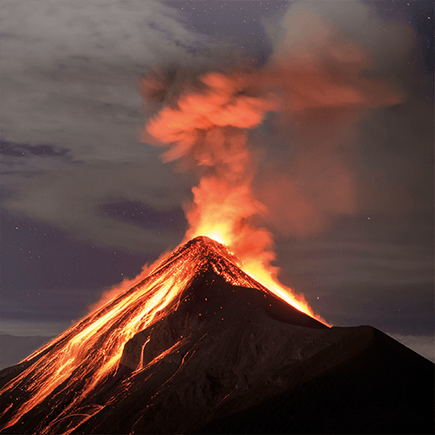  Through the Ages-History |  |  |  |  |  |  |  | 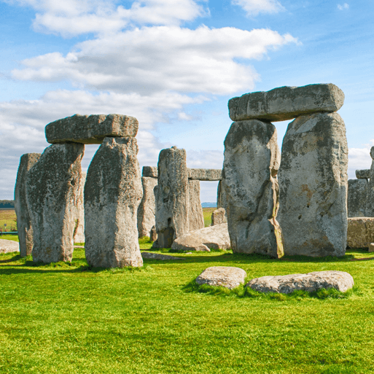  Rock, Relics and Rumbles-Geography |  |  |  |  |  |  | 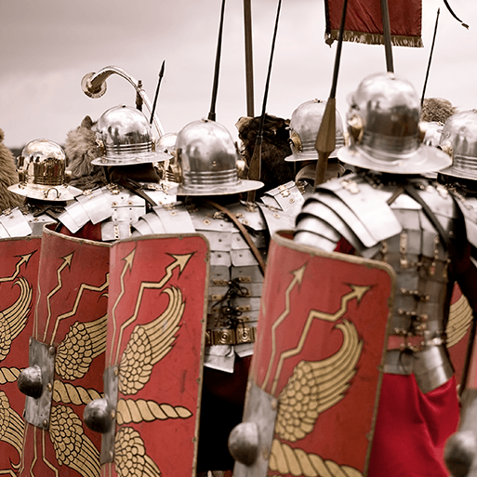  Emperors and Empires-History
 | English pack genres |  | Narratives | Instructions |  |  | Cinquains |  |  | Chronological reports | Non-chronological reports | Shape poems |  |  | Newspaper reports |  | Diaries | Biographies | Letters |  |  | Myths |  |  |  | Poems
 | Whole Class read
 | Mini projects | Science | Skeletal and muscular systems (3)  Lights and shadows (3)  Digestive system (4)  Sound (4) |  |  |  |  |  |  |  | Rocks(3)  Forces and Magnets (3)  States of Matter (4)  Grouping and classifying (4) |  |  |  |  |  |  | Plants (3)  Electrical circuits and conductors (4)
 |  | Art | Contrast and complement |  |  |  |  | Prehistoric Pots |  |  | Ammonite |  |  | People and places |  |  |  | Beautiful botanicals |  |  |  |  | Mosaic masters
 |  | DT | Cook well, eat well |  |  |  |  |  |  |  | Making It Move |  |  |  |  |  |  | Greenhouse
 |  | Geog | Pre-requisites for Year 3- some Let's explore the world |  |  |  |  |  |  |  | Covered in main project |  |  |  |  |  |  | Geography revision and retrieval practice
 |  | History | Covered in main project |  |  |  |  |  |  |  | Recap and Revision |  |  |  |  |  |  | Covered in main project
Year 3 and 4 Cycle A | Main |  | 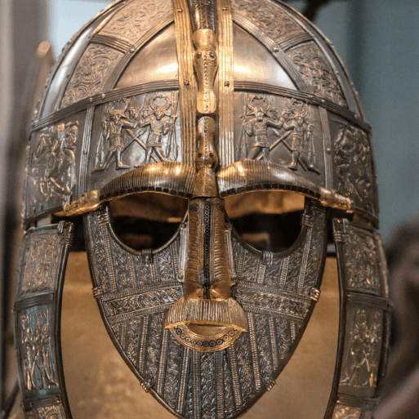  Invasion-History |  |  |  |  |  |  |  | 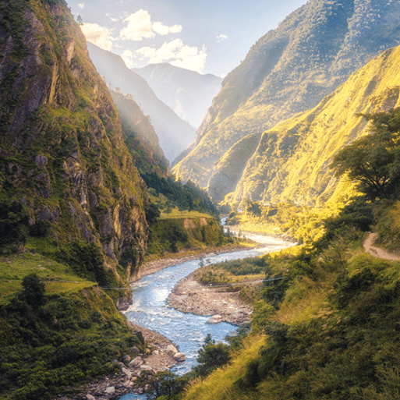  Misty Mountain, Winding River-Geography |  |  |  |  |  |  | 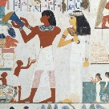  Ancient Civilisations-History
 | English pack genres |  | Anglo-Saxon poems | Playscripts |  |  | Norse myths |  |  | Non-chronological reports | Diaries | Leaflets |  |  | Explanations |  | Narrative poems | Free verse poems |  | Instructions |  |  |  |  | Stories from other cultures
 | Whole class read
 | Mini projects | Science | Skeletal and muscular systems (3)  Digestive system  (4) |  |  |  |  | Lights and shadows (3)  Sound (4) |  |  | Rocks(3)  States of Matter (4) |  |  | Forces and Magnets (3)  Grouping and classifying (4) |  |  |  | Plants (3)  Electrical circuits and conductors (4)
 |  | Art | Contrast and complement |  |  |  |  | Warp and Weft |  |  | Vista |  |  | Animal |  |  |  | Statues, Statuettes and Figurines |  |  |  |  | Islamic Art
 |  | DT | Fresh Food, Good Food |  |  |  |  |  |  |  | Functional and Fancy Fabric |  |  |  |  |  |  | Tomb Builders
 |  | Geog | Pre-requisites for Year 4- some One Planet, Our World |  |  |  |  |  |  |  | Covered in main project |  |  |  |  |  |  | Geography revision and retrieval practice
 |  | History | Covered in main project |  |  |  |  |  |  |  | Recap and Revision |  |  |  |  |  |  | Covered in main project
Year 5 and 6 Cycle B | Main |  | 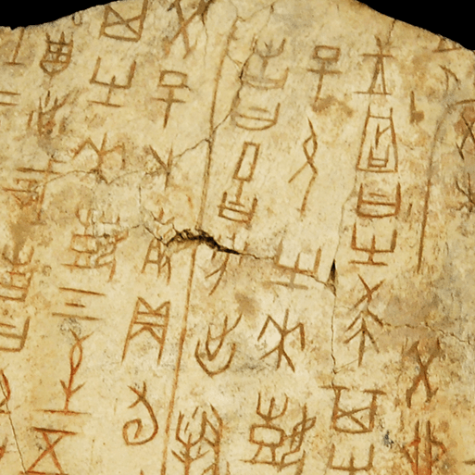  Dynamic Dynasties  History |  |  |  |  |  |  |  | 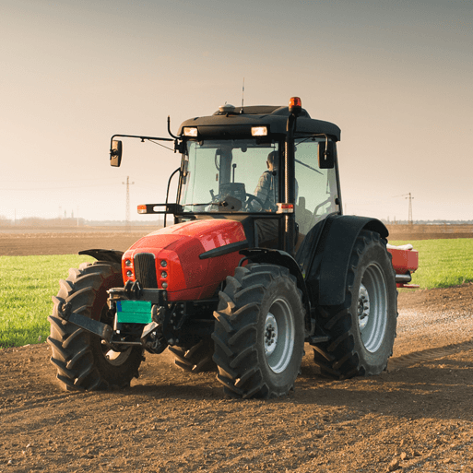  Sow, Grow and Farm  Geography |  |  |  |  |  |  | 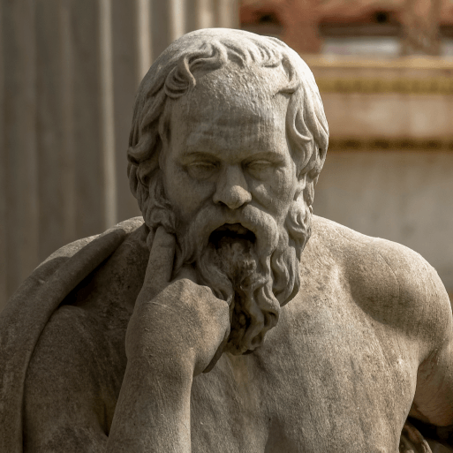  Groundbreaking Greeks  History
 | English pack genres |  | Narrative poems |  |  | Biographies |  |  |  | Stories from other cultures | Non-chronological reports | Diaries |  |  | Leaflets |  | Balanced arguments | Greek myths | Balanced arguments |  |  | Playscripts |  |  |  | Odes
 | Whole Class Read
 | Mini projects | Science | Forces and mechanisms (Y5)  Circulatory System (Y6) |  |  |  |  | Earth and space (Y5) |  |  | Human Reproduction and ageing (Y5)  Electrical circuits and Components (Y6) |  |  |  |  |  |  | Properties and changes of materials (Y5)  Light Theory (Y6)  Evolution and Inheritance (Y6)
 |  | Art | Tints, Tones and Shades |  |  |  |  | Taotie |  |  | Light, Line and Shadow |  |  | Nature's Art |  |  |  | Mixed Media |  |  |  |  | Expression
 |  | DT | Moving mechanisms |  |  |  |  |  |  |  | Eat the Seasons |  |  |  |  |  |  | Architecture
 |  | Geog | Pre-requisites for Year 5- some Interconnected World |  |  |  |  |  |  |  | Covered in main project |  |  |  |  |  |  | Geography revision and retrieval practice
 |  | History | Covered in main project |  |  |  |  |  |  |  | Recap and Revision |  |  |  |  |  |  | Covered in main project
Year 5 and 6 Cycle A | Main |  | 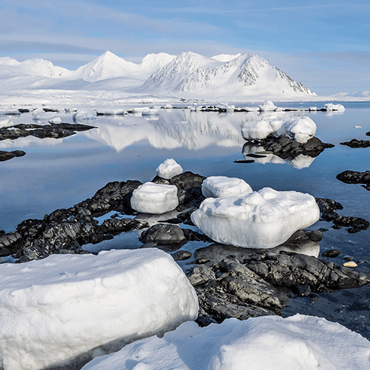  Maafa  History |  |  |  |  |  |  |  | 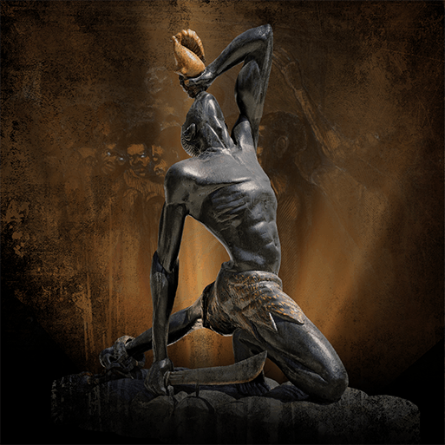  Frozen Kingdom  Geography |  |  |  |  |  |  | 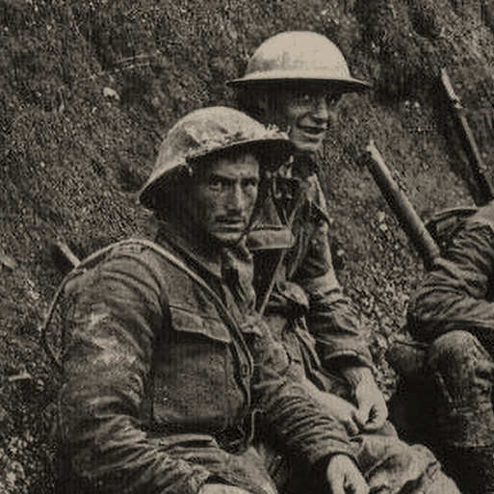  Britain at War  History
 | English pack genres |  | Newspaper reports | Persuasive letters |  |  | Non-chronological reports |  |  | Acrostic poems | Non-chronological reports | Haikus |  |  | Newspaper reports |  | Adventure narratives | Persuasive posters |  |  | Historical narratives |  |  | Nonets
 | Whole class read |  |  |  |  |  |  |  |  |  |  |  |  |  |  |  |  | Goodnight Mister Tom
 | Mini projects | Science | Earth and space (Y5)  Forces and mechanisms (Y5)  Circulatory System (Y6) |  |  |  |  |  |  |  | Human Reproduction and ageing (Y5)  Electrical circuits and Components (Y6) |  |  |  |  |  |  | Properties and changes of materials (Y5)  Light Theory (Y6) |  |  |  |  | Evolution and Inheritance (Y6)
 |  | Art | Tints, Tones and Shades |  |  |  |  | Trailblazers, Barrier Breakers |  |  | Inuit |  |  | Environmental Artists |  |  |  | Distortion and Abstraction |  |  |  |  | Bees, Beetles and Butterflies
 |  | DT | Food for Life |  |  |  |  |  |  |  | Engineer |  |  |  |  |  |  | Make Do and Mend
 |  | Geog | Pre-requisites for Year 6- some Investigating our world |  |  |  |  |  |  |  | Covered in main project |  |  |  |  |  |  | Geography revision and retrieval practice
 |  | History | Covered in main project |  |  |  |  |  |  |  | Recap and Revision |  |  |  |  |  |  | Covered in main project

